UofL Research and Innovation Website

Vision (Small Project)

Joseph Baxter, Robert Burch, Mohammed Al Madhi, Meelan Mishra, Nathan Moran, and Scott Pettyjohn

Version 2.1

Revision History

|  |  |  |  |
| --- | --- | --- | --- |
| **Date** | **Version** | **Description** | **Author** |
| 29/Jan/20 | 1.0 | Sections 4 – 6 | Scott Pettyjohn  Nathan Moran |
| 29/Jan/20 | 1.0 | Section 3 | Joseph Baxter  Robert Burch |
| 29/Jan/20 | 1.0 | Section 1 – 2 | Mohammed Al Madhi  Meelan Mishra |
| 19//Feb/20 | 2.0 | Added economic argument tables | Joseph Baxter |
| 2/March/20 | 2.1 | Added feasibility analysis | Scott Pettyjohn |

Table of Contents

1. Introduction 4

1.1 References 4

2. Positioning 4

2.1 Problem Statement 4

2.2 Product Position Statement 5

3. Stakeholder and User Descriptions 5

3.1 Stakeholder Summary 5

3.2 User Summary 6

3.3 User Environment 6

3.4 Summary of Key Stakeholder or User Needs 7

3.5 Alternatives and Competition 7

4. Product Overview 8

4.1 Product Perspective 8

4.2 Assumptions and Dependencies 8

5. Product Features 8

6. Other Product Requirements 8

7. Feasibility Analysis 9

Vision (Small Project)

# Introduction

The purpose of this document is to collect, analyze, and define high-level needs and features of the University of Louisville Research and Innovation websites. It focuses on the capabilities needed by the stakeholders and the target user, and why these needs exist. The details of how the University of Louisville Research and innovation fulfills these needs and are detailed in the use-case and supplementary specification.

## References

1. Feasibility Analysis

# Positioning

## Problem Statement

|  |  |
| --- | --- |
| The problem of | The University of Louisville Office of Research and Innovations is currently running and operating on a system with limited capabilities that lacks its ease of use which includes, information overload, spending statistics and inactive social media accounts. |
| Affects | Student, Faculty and Staff. |
| The impact of which is | Lack of ease of use between the data and the users |
| a successful solution would be | Development of an organized website with a simple and fast processing methodology. |

## Product Position Statement

|  |  |
| --- | --- |
| For | Students, Faculty, Staff and Researchers |
| Who | Can benefit from the new implemented organized |
| The (product name) | University of Louisville Office of Research and Innovation Website |
| That | Will benefit from our organized design |
| Unlike | Having website that includes difficulty of use and information overload |
| Our product | Will include simple methodology for ease of use, which will allow our stakeholders to benefit from our organized web design. |

# Stakeholder and User Descriptions

## Stakeholder Summary

|  |  |  |
| --- | --- | --- |
| **Name Name** | **Description** | **Responsibilities** |
| Students | Student users who are interested in learning more about, or volunteering for research and innovation projects | Student needs will help shape the site into being more user friendly as well as determining site content |
| Researchers | Research staff who use the site to access systems | Researcher needs will shape the site into being more user friendly as well as determining site content |
| Staff | R&I staff, including non-researchers | Faculty will monitor project progress and help decide the final design and provide content |
| Community | Larger body of individuals who gather information from the site | Community needs will help shape site content; different communities will result in different types of content being presented |
| Administrators | High level employees | Approves product design. |

## User Summary

|  |  |  |  |
| --- | --- | --- | --- |
| **Name** | **Description** | **Responsibilities** | **Stakeholder** |
| Students | UofL students who wish to know more | No direct responsibilities, but their needs help shape the website | Students |
| Researchers | Research and Innovations staff directly associated with projects | Help Provide content for site | Researchers |
| Staff | Those in charge of the site | Requested system, provide content and information, monitor project progress. | Staff |
| Community | Internal and external communities | Drive revenues, target customers | Community |

## User Environment

Main time sink of the site is editing content to match current state of Research and Innovation Projects and potential grants or opportunities. Exact amount of time spent making these edits cannot be ascertained, however it is our goal to reduce these times.

Site mainly needs to work on desktop versions of popular web browsers, a mobile version is not a high priority. Current Content management system is Plone, however, the site currently does not employ a payment management system.

## Summary of Key Stakeholder or User Needs

Issue of a lack of navigational ability on the website due to poor organization and structuring. The solution would be to redesign and organize the website to make it more accessible for user which also aligns with the desired stakeholder solution.

Issue regarding a lack of a Payment Management System as when the site was constructed the implementation of a PMS was forgone. This solution would be solved by finding a PMS that integrates well with our CMS and would solve the stakeholder’s desire to incorporate a way to handle money through the site.

|  |  |  |  |  |  |
| --- | --- | --- | --- | --- | --- |
| **Need** | **Priority** | **Concerns** | **Current Solution** | **Proposed Solutions** | |
| Reorganization of website | High | Lack of organization causes user issues | No actions have currently been taken towards solving this issue | | Restructure and reorganize the website to enhance navigation and usability |
| Institution of Payment Management System (PMS) | Medium | Lack of method of handling monetary transactions for website | No actions have been taken currently to address this issue | | Find a PMS that is compatible with our CMS and integrate it into the website to allow payment management |

## Alternatives and Competition

* Stakeholders may choose to go with a design produced by our colleagues. Perhaps the design of the other teams meets their business goals more effectively. However, all teams are working off the same information so true differences between them cannot be seen until further along in the process.
* Stakeholders may decide to maintain the website as is, however this would mean ignoring the problems the website has in favor of the status quo.
* Stakeholders may decide to go with an external entity to have the website redesigned. The site would have a greater chance of meeting their business goals, but this outcome would be significantly more costly.

# Product Overview

## Product Perspective

The system would be very similar to other Research and Innovation websites from universities across the nation. It would also offer many of the same services and information that they would, but only related to the R&I department at UofL. It would consist of a content management system and a payment system that enables the website to compete with other schools in terms of usability and function.

## Assumptions and Dependencies

It would be assumed that users find the current R&I website frustrating. That is why many of the suggested changes are being brought forward. Those at R&I want a functional website that is easy to navigate and fits the theme of “research and innovation” and “cutting edge.”

# Product Features

* Allows faculty and others to find available grants in an easy way. Will have a section dedicated to funding and grants with all the relevant information stored there as well so it’s accessible.
* Allows users to find other people and departments to collaborate with. A section or form that lists people with the relevant contact information to facilitate partnerships and collaborations.
* Forms that are available to be filled out and submitted in one place
* It will contain a social media widget. This will show recent posts and updates made across different social media platforms, most likely on the landing page. It’s a simple way of plugging the R&I social media accounts to any users that may come across the website.
* Overall navigation that’s simple and easy to follow. No unnecessary links and information scattered all over the place. Should quickly facilitate users to where they want to go.

# Other Product Requirements

* Would have to meet the physical appearance requirements. School colors only and all the other appropriate branding.
* A content management system to build and host the website.
* Meet any of the technical standards that are required of the website

# Feasibility Analysis

* 1. **Technical**

The website could be made with Plone and WordPress, which are both open source and free management systems.  There is some flexibility in which Management Systems we will use but as is they both are ideal since they meet the requirements for hardware needs.

The bare minimum for this website would be:

1. A CMS that can incorporate data bases and other systems as well as possess the ability to customize and give structure to R&D’s website.

2. A PMS that can process and sort monetary transactions that pass through the website; Grant money is one of the most important business processes that R&D oversees so its priority ranks high on the list of needs to be met.

* 1. **Economic**

There are three different economic projections for the Research and Innovation team after following through with our plan. The three projections are broken down in the following tables: Table 1 (Low), Table 2 (Realistic), and Table 3 (High). They show the economic projections for 2 additional grants, 5 additional grants, and 10 additional grants. The average grant amount was calculated in order to give each additional grant a value and make an accurate projection on the economic benefit of following through with the project. With low costs, each of the three projections manages to have an early break-even point, high return on investment, and a high net present value.

Table 1

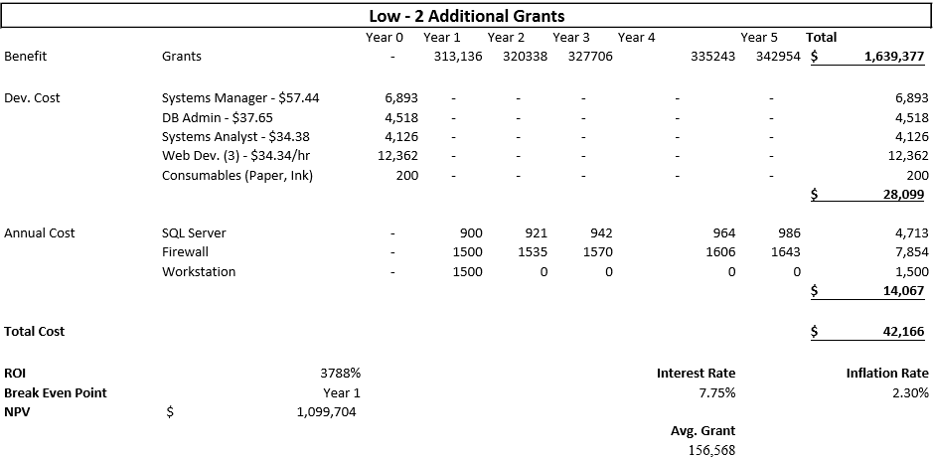

Table 2

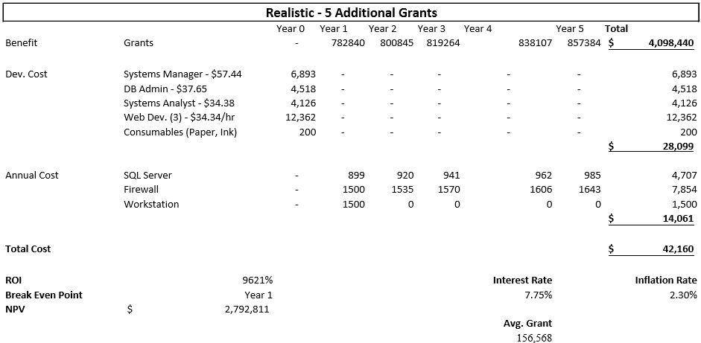

Table 3

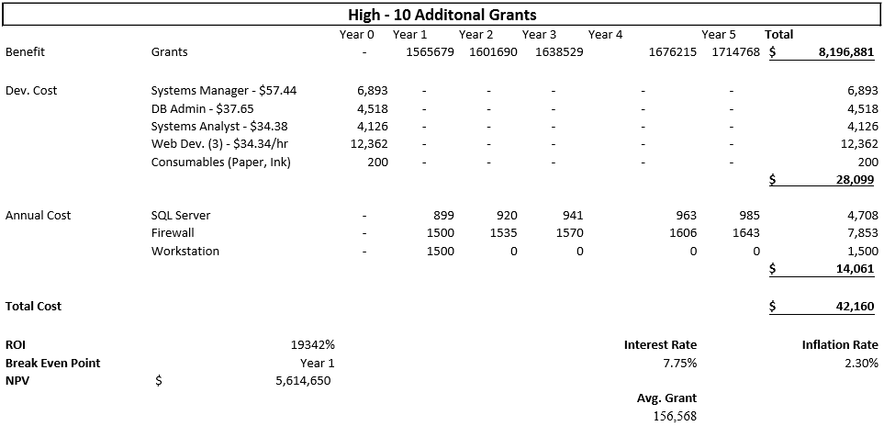

* 1. **Organizational**

One of the major concerns with this project is not with the end-users, but with the staff/faculty of R&I and their organization. The major consideration with this facet of the project is that the product we’re looking to produce should have high compatibility with pre-existing structures, codes, protocols, etc. We would want to look at how the current website is integrated into the R&I organization and use that as a model for our own so that the change wouldn’t be jarring. Some important business factors to consider would be company policies, hierarchies, ethics codes, branding regulations, company expectations, etc.

**System Request**

Project: Website Revision

Organization:University of Louisville

Department:  Research and Innovation

**Business Needs**

Research is very important to the University of Louisville, both as a means of achieving academic excellence and as a source of revenue. Our client, UofL’s Department of Research and Innovation needs a new website to run their organization and business processes through. Their current website suffers from issues like too much non-important information, a poor user interface, a lack of statistics, and poor overall organizing and design choices.

**Business Opportunities**

We hope that in taking this opportunity to try to improve R&I’s website, we might be able to increase revenue by attracting more clients and lower existing costs by reducing time spent managing the website by the staff of R&I.

**Desired Functionalities**

Priority           Feature

High Implementation of powerful and flexible Content Management System and Payment Management System

High                  Restructured and more user-friendly UI

High                  Implementation of database technologies

Medium        Ability to track movement of people & money through the R&I system

**Expected Value**

We believe that upgrading and improving R&I’s website has the potential to gain anywhere from 2-10 new grants on average with 5 being the most realistic estimate. Since each grant averages around $150,000, the low end would see an additional $300,000 in revenue and the high end would see an additional $1,500,000 in revenue. Realistically though, 5 more grants would bring in an additional $800,000 in revenue. It’s also possible that the improvements might help significantly cut down maintenance time on the website. Although not measurable, the modifications could also help to improve user experiences and satisfaction levels.

**Process Models**

**As-Is process model**

The As-Is process model (Figure 1) describes the system that university of Louisville Research and innovation is currently using. They use Research supports tab for primary sources for funding information. Inside this tab there are many options but none of them support the funding statistics, just information on federal grants and how to apply for funds. The home page is where news and events are located, however, not in a clear and organized way. The About Us tab is primarily used for contract information and social media interaction. The problem with the About Us tab is that it is harder for user to get into the social media interaction. User must click on the about us tab and then into the contact tab to get into the social media interaction.

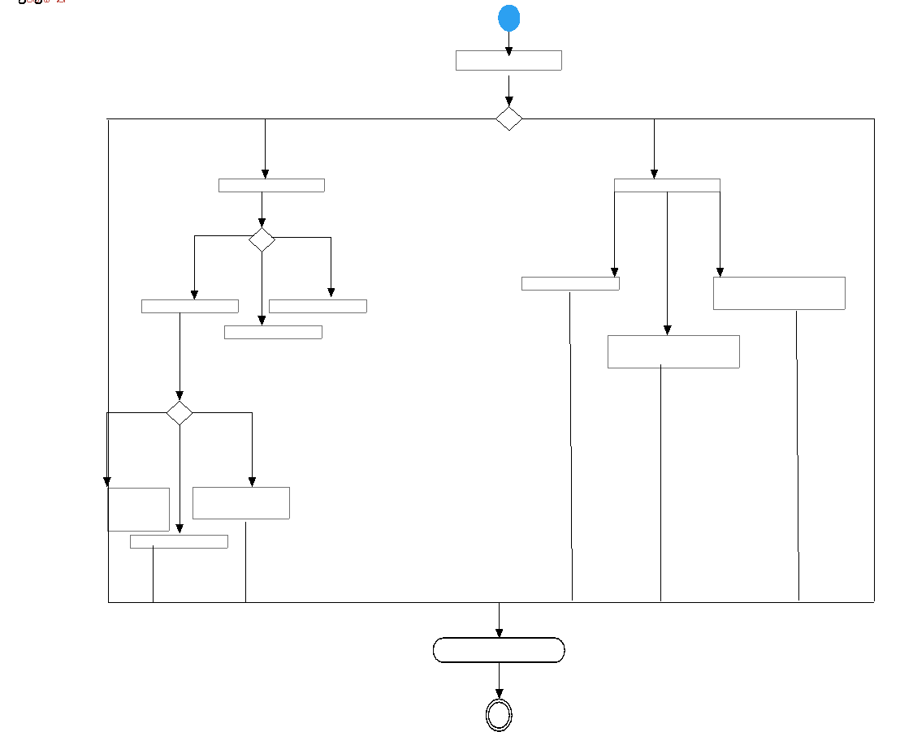

Home Page

News and Announcements

Research Support

Research Page

Engagement

Research and Innovation Successes

Find Funding

Award Management

Award Lifecycle

Events

Federal Grants

Internal Grants

Award Lifecycle

Figure 1

**To-Be process model**

The To-Be process model (Figure 2) show the changes that will improve upon the existing site. University of Louisville Research and Innovation is still using Researchers Support as the primary sources of funding information. But now merging into the Award Lifecycle tab on award management link we added spending statistics. Adding spending statistic tab helps all internal and external user to know inflow and outflow of funding in the organization. This will help donors more involving in funds. The home page is still running same as before. Its primary purpose is to give the information about the events, news, etc. Instead of having the link of events, news, and innovation successes directly on the homepage, we merged those tabs into the homepage. This will make the site more organized and easier to navigate.

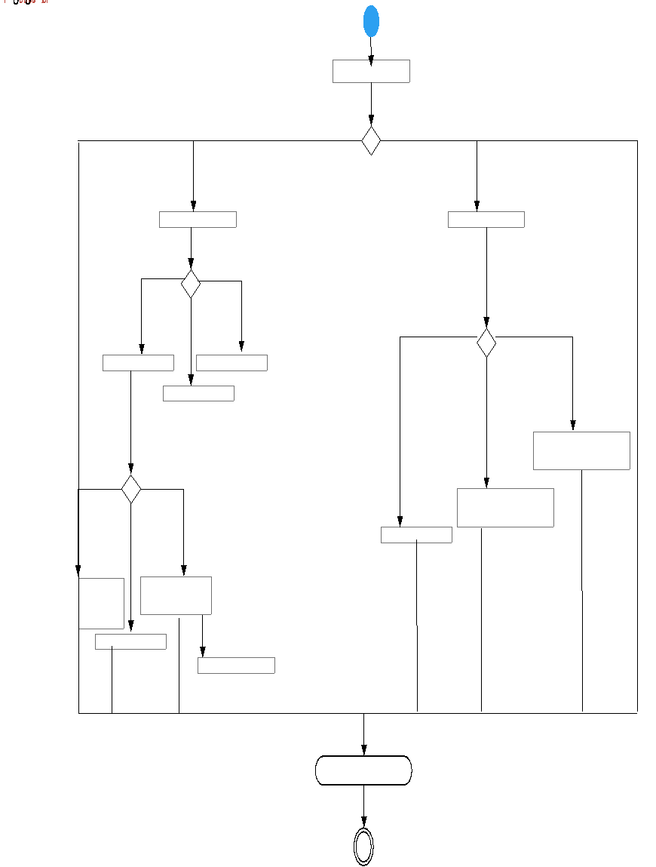

Engagement

Award Lifecycle

Spending Grants

Events

News and Announcements

Home Page

Research Support

Research Page

Award Management

Find Funding

Research and Innovation Successes

Award Lifecycle

Federal Grant

Internal Grants

Figure 2

**System Requirements**

System Requirements are what the system must do or what characteristics it needs to have. It’s important to understand who will use the system, what the system will do, and where and when it will be used. System Requirements are broken down into Functional Requirements and Nonfunctional Requirements.

**Functional Requirements**

Functional requirements relate directly to a process the system must be able to perform or information it must possess. They describe how the system behaves and the functions of the system. The functional requirements for this project include:

**Process-oriented**

* 1. Will allow administrators to add, edit, and delete entities for stakeholders (researchers, students, industry, community, and event attendees)
  2. Will allow administrators to add, edit, and delete entities for events
  3. Will allow administrators to add, edit, and delete entities for grants
  4. Will allow users to send messages directly to the UofL Office of Research and Innovation through contact us form.
  5. Will allow administrators to add, edit, and delete entities for surveys and create reports on surveys
  6. Will allow attendees to keep track of and RSVP for events
  7. Will allow administrators to upload and download files.
  8. Will allow administrators to add, edit, and delete pages.
  9. Will allow users to log in to user-created profiles
  10. Will direct potential donations to Development
  11. Will use logins as preconditions for user-related functions

**Information-oriented**

* 1. Will save search results for users
  2. Will include current and upcoming events for users to view
  3. Will include statistics and facts related to R&I
  4. Will include updates on current and future projects

**Nonfunctional Requirements**

Nonfunctional Requirements refer to behavioral properties. This includes the performance and usability of the system. If it doesn’t produce information for the user, it is nonfunctional. These requirements are usually related to scalability, reliability, data integrity, and more.

**Operational**

* 1. Will be capable of running on Windows, Mac, and other relevant environments
  2. Will be integrated into the current system.
  3. Will be optimized to operate on properly on desktops, mobile devices, and tablets.
  4. Will be capable of running on any Web browser
  5. Will run on an efficient Content Management System, such as WordPress

**Performance**

* 1. System will be more user-friendly.
  2. System will be easy navigate.
  3. The system will be operational 24/7.
  4. System will execute in two seconds or less.
  5. System will update social media feeds every minute.
  6. System will be organized well and be informative.
  7. System will run functional calendar and events

**Security**

* 1. System will include industry-standard security measures/safeguards
  2. System will have a proper backup and recovery protocol
  3. System will update when necessary
  4. System will have varying levels of privilege so that the relevant information is available to a specific user and nothing

**Use Cases**

Use cases are formal ways of showing how our business system (the website), will interact with users. It will have a specified name having to do with the actions taking place. The name will be a shortened version of the description to give insight to the particular use case. Actors are merely the user that is interacting with the business system.**Use Case Name:** Create Stakeholder (Student, Researcher, Community, Industry, Event attendee)

**Actor:** Administrator

**Short Description:** This use case describes how administrators will create entities for each stakeholder

**Use Case Name:** Edit Stakeholder (Student, Researcher, Community, Industry, Event attendee)

**Actor:** Administrator

**Short Description:** This use case describes how administrators will edit entities for each stakeholder

**Use Case Name:** Delete Stakeholder (Student, Researcher, Community, Industry, Event attendee)

**Actor:** Administrator

**Short Description:** This use case describes how administrators will delete entities for each stakeholder

**Use Case Name:** Create Events/Grants

**Actor:** Administrator

**Short Description:** This use case describes how administrators will addevents and grants to the site

**Use Case Name:** Edit Events/Grants

**Actor:** Administrator

**Short Description:** This use case describes how administrators will edit events and grants for the site

**Use Case Name:** Delete Events/Grants

**Actor:** Administrator

**Short Description:** This use case describes how administrators will delete events and grants for the site

**Use Case Name:** Edit Website

**Actor:** Administrator

**Short Description:** This use case describes how administrators will edit the R&I website

**Use Case Name:** User Navigation

**Actor:** Website User

**Short Description:** This use case describes how users can more easily navigate the website

**Use Case Name:** Find Grants

**Actor:** Faculty

**Short Description:** This use case describes how faculty can find available grants.

**Use Case Name:** Browse Social Media

**Actor:** Community

**Short Description:** This use case describes how the community will be able to view social media content.

**Use Case Name:** Fund Grants

**Actor:** Companies

**Short Description:** This use case describes how companies can fund grants.

**Use Case Name:** Research Applications

**Actor:** Students

**Short Description:** This use case describes how students can find research to partake in.

**Use Case Name:** Research Statistics

**Actor:** Community

**Short Description:** This use case describes how the community can view current and past research.

**Use Case Name:** Find Events

**Actor:** Community

**Short Description:** This use case describes how the community can view upcoming events on the calendar.

**Use Case Name:** Find Contact

**Actor:** Students, visitors and administration

**Short Description:** This use case describes how Students and Visitors send emails directly to the University of Louisville Office of Research and Innovation through an embedded contact form.

**The Architecture Considerations**

The base viewpoint is called the Design Viewpoint (Diagram 1). This viewpoint takes the project down to a minimalist view of all the components of a system. This viewpoint also depicts how all the components will interact with one another once the system is fully implemented.

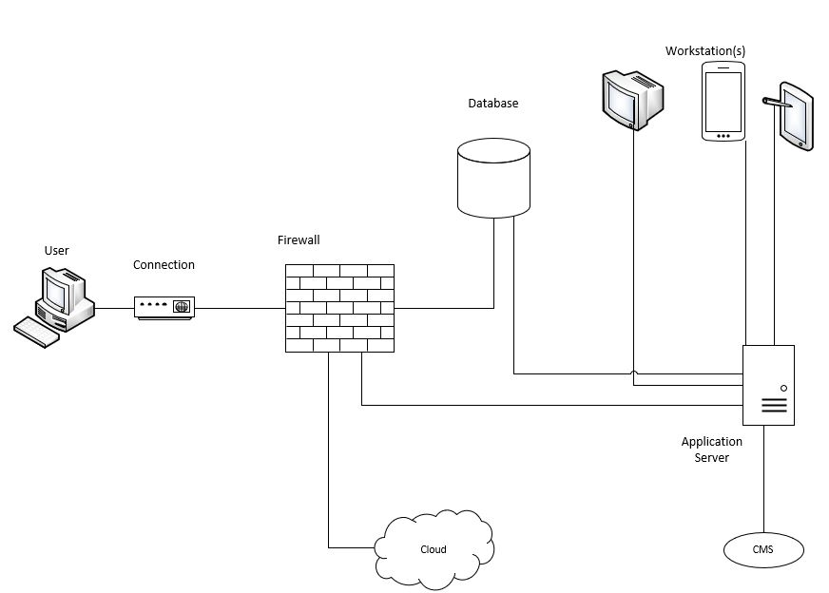

Diagram 1

The Realization Viewpoint (Diagram 2) is the actualization of the Design Viewpoint. The Realization viewpoint takes the components and their connections and replaces general tags on component items with the names of the technology that will be used to bring the system to life.

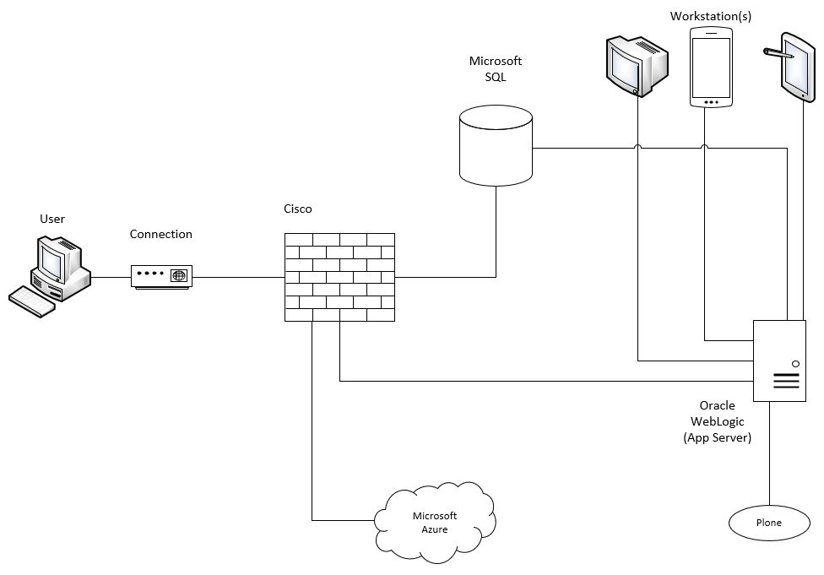

Diagram 2

**Risk Assessment**

**Use Cases**

Use case risk will be based on the probability that the case could result in additional monetary costs, increase development time, or if poor execution could result in a decreased functionality or usability of the site

**Risk 1:** User Navigation

**Probability:** High

**Impact:** Largest component of new design. Dictates the rest of the website

**Ways to address:**

User navigation is a large part of the new design. It is important that the new design allows users to navigate around the site efficiently, find the information they need without having to sift through a large amount of links, and encounter no dead links or redundancies. Studying other websites could be very telling for what best practice is. Organizing the site to where each user type has their own path is also a good option as each series of pages would only contain the information needed for each type of user.

**Risk 2:** Finding Grants

**Probability:** High

**Impact:** Not providing accurate and complete information will prevent people from returning to the site

**Ways to address:**

Highly important that we can provide accurate grant information to users. Incomplete or outdated information could sour the user’s experience and prevent them from using the site again. Creating an easy to manage site would allow for the rapid update of relevant content

**Risk 3:** Social Media

**Probability:** Low

**Impact:** Lack of social media presence prevents us from reaching potential new users and providing updates to subscribers

**Ways to address:**

Creating social media accounts for Research and Innovation, or better utilizing the ones we already have will allow us to reach new users both internal and external, as well as providing frequent news updates to current subscribers. Implementing a posting schedule for the accounts will make us seem more active. Inserting social media plugins or widgets to the website will help convince users to subscribe.

**Risk 4:** Funding Grants

**Probability:** High

**Impact:** Online grant applications would be a major draw to the site

**Ways to address:**

Providing a way for users to connect with grant funding via online forms would be a massive boom for the site. These forms would need to be easily accessible and gather enough information to begin the grant funding process. This method of streamlining will expedite the funding process and make users more apt to use the site in the future.

**Risk 5:** Events

**Probability:** Low

**Impact:** Allowing users to view information on research events keeps users coming back and makes the site more active

**Ways to address:**

Events could either have its own area on the main landing page or have its own page. The events page needs to be laid out with events in chronological order and needs to be updated frequently

**Risk 6:** Research Applications

**Probability:** High

**Impact:** Allowing companies to promote grants is a source of revenue

**Ways to address:**

It’s highly important we allocate space on the site for the promotion of internal and external grant opportunities. Allowing companies to have their offerings represented will help connect internal and external users with funding, generating more revenue for the University while also allowing for the opportunities provided by the University itself to promote its own opportunities. Pages devoted to these opportunities should be easy for all interested parties to find.

**Risk 7:**  Research Statistics

**Probability:** Low

**Impact:** Allowing users to see research related statistics is a good way to promote the effectiveness of UofL R&I

**Ways to address:**

A page for viewing research data and statistics could serve to promote interested parties into choosing us for their research needs. Additionally, it would allow internal and external users to have access to whatever data we allow to be released, to be used in their own projects. To achieve this, we could have the page organized by research category which could link to downloadable zip files with the relevant data, or we could use a cloud service to store the data.

**Risk 8:** Contact

**Probability:** High

**Impact:** Contact information being available is crucial

**Ways to address:**

Many universities have contact information for getting in touch with R&I at the bottom of every page. The current site has a page that also contains individual contact information for faculty. Adding a webform for directly emailing R&I without having to leave the site could be beneficial.

**Other Risks**

Risks will be based on the probability that the risk could result in additional monetary costs or an increase in development time

**Risk 1:** Development of this system will be delayed by the developers’ unfamiliarity with Plone

**Probability:** High

**Impact:** Could lengthen development time considerably

**Ways to address:**

Programmers need to be given a well-documented outline of the chosen design and should be given access to relevant CMS documentation that the R&D faculty may possess. If available, faculty that maintained the original site should be consulted

**Risk 2:** Database integration will increase development time

**Probability:** Low

**Impact:** Increase in development time

**Ways to address:**

Continuing to use old databases but modifying them to be compatible with current systems could be an easier task then rebuilding everything from scratch. Choosing user friendly database management system could ease the development

**Risk 3:** Database needs could be greater than originally anticipated.

**Probability:** Low

**Impact:** Could incur additional costs

**Ways to address:**

Additional resources allocated to the database could add a significant cost. Budgeting for a greater amount of database resources than we think we need could account for this. A cheaper option would be choosing a database provider with a cheaper plan, or maybe hosting our own database on the University's servers.

**Risk 4:** New website design is inefficient or less easily navigable by users

**Probability:** Low

**Impact:** Potential loss in site revenue and traffic

**Ways to address:**

Increasing site revenue via developing a new user interface that's easier to navigate is the purpose of the project. It is a possibility that our best efforts could result in a site that has no actual improvement over the original. The best defense against this is to carefully analyze what aspects of the site are lacking and to flesh out ways of improving through prototyping, testing, and tailoring the site to the needs of distinct user groups

**Team Charter**

**Team Communication**

Among our team members, most of our communication is outside of class due to class schedules and some of us have jobs, which wouldn't allow us to meet often. We are also using Google Drive to store and share our documents which our team can collaborate on the same file at the same time with its live editing feature, in our class our team discusses changes and ideas that could improve each other’s work. Lastly, questions regarding class work and the client will be made via email.

**Team Decisions**

Consensus will be reached by allowing each team member equal opportunity to express their ideas, and each member's ideas will be discussed until they are either implemented, or it is sufficiently explained why such an idea would not benefit the design. Decisions on these ideas will be based off majority opinion, although it is the goal that each idea implemented is unanimous. Should conflicts arise, each side will make their case and then discussions will resume until such a time that one side of the conflict cedes their stance, or an amicable compromise is reached.

**Project Repository**

Documentation will be kept in a shared google drive folder, organized by iteration. Each team member will also keep copies of their work on their personal machines. Documents will be scanned by each member to make sure there is consistency in formatting, as well as making sure that the content represents the entire team. When work is due to be turned in, one team member will be selected to print out the deliverables to be placed within the portfolio.

**Team Meeting**

Team meetings are decided on in person or via GroupMe. There group members can communicate when the best time to meet is and where. During meetings, what is needed to be done is discussed, followed by how it will be completed, finished with the individuals who are responsible for the specific tasks. Our meetings are to be as focused on our goals and what needs to be done as possible. After that, group members can work on the tasks given as well as ask questions about those same tasks. Meetings can last any amount of time. If group members know their tasks, they can be short but if more work and communication is needed, they can be lengthened. Meeting decisions are immediately sent to the GroupMe. This way, all information needed down the line is easily accessible to all and clearly laid out.

**Team Goals**

The goals created will be time based and member based. In order to get all tasks completed well and on time, due dates for the group are established. Proper due dates allow members to have enough time to work on their duties, as well as enough time on the back end for changes and uniformity to be applied. If goals need to be altered, they may be talked about within meetings and/or GroupMe. Our main goal is to communicate as clearly and purposefully as possible, allowing our work to prosper.

**Gantt Chart**

This Gantt Chart lists the tasks of a project and the duration of how long tasks will take, as well as their dependencies.





**Inception Phase Prototypes**

For this project, we created two prototypes of how we envision the new Research and Innovation website working. In Figure 1, you see the new and improved landing page. At the top, you will notice that the tabs have been altered so that they are stakeholder oriented. The main people that will be interacting with the site have a separate tab where any relevant information they need can be found. The rotating banner remains the same as before. Below that is where many of the changes take place: infographics for R&I statistics, a place to search for connections, a twitter widget, an events section, and links to social media and the newsletter.



Figure 1

In Figure 2, you see what a potential form may look like on the website. The one showed is the Industry Request Form. If possible, we would like to transfer some of the forms located in document files over to web forms, like the Industry Request Form. With these forms, all proper data validation will be used so that there are minimal problems when users submit forms.



Figure 2